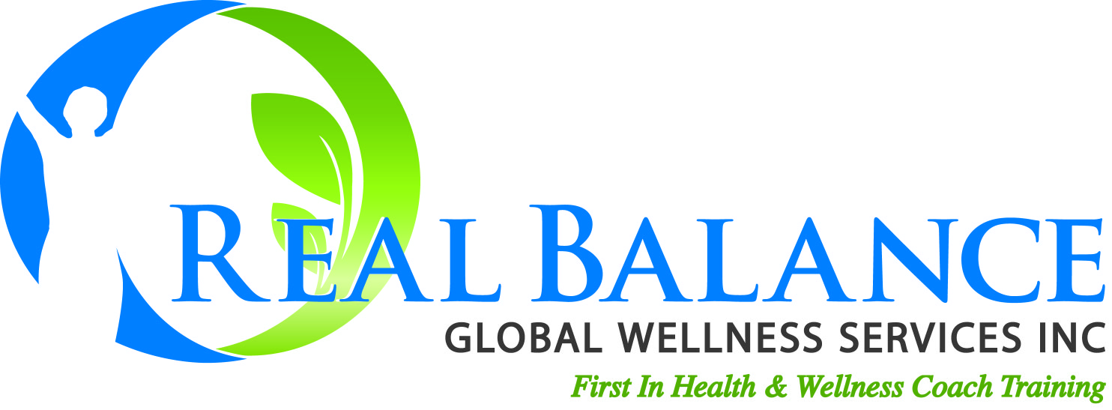
www.realbalance.com

The Wellness Coach’s Value Proposition*

“Thank you for your interest in improving your lifestyle and your life. You may be new to coaching, and especially wellness coaching, so let me share with you the value that it brings.

Wellness/health coaching is all about you living the best life possible for you. To do that most people find there needs to be some improvements in their way of living, their lifestyle. Making those improvements, those changes is challenging when you have to do it all by yourself. Perhaps you’ve already had some experience with that.

When I work with someone in coaching I’m here to serve you. You are the one in charge of your life and our work together. It’s your hands on the steering wheel. I’m not going to tell you what to do and give you a pre-maid wellness plan. But, together we can co-create a plan to help you succeed at making the lifestyle improvements that you want to make.

As your coach I will be working with you to get very clear about where you are at with your health and well being right now. We’ll help you take stock of that by exploring together, using some coaching tools that will help give you a more complete picture, and by going over the lifestyle improvement recommendations you’ve gotten from treatment professionals. Then we’ll work together to help you form a clear picture of the kind of life you want to live, your healthiest life possible for you. We’ll compare where you’re at and where you want to be and together form a solid plan to help you get there.

Once we have that plan we’ll work together as allies to help you be accountable to yourself and follow through on the steps you need to be taking on a regular basis to help you achieve the goals you have in your plan. I’ll be with you throughout the journey. I’ll be there to help you strategize over, under, around and through the barriers that come up. I’ll help you with challenges that make it tough for you to live the healthy life you want and together we’ll help you keep on track. Together we’ll help you find and develop the sources of support that will make your changes last. We’ll evaluate our progress and adjust the course along the way as we need to. My goal is to assist you in becoming self-sufficient in your wellness, to be able to live a healthy life in a completely sustainable way.

I bring the value of a professional that knows about succeeding at lifestyle improvement. I bring the value of an ally.”

*(Created by Michael Arloski, Ph.D., PCC, CWP) Please adapt to your own words and use it!
If used intact you must include authorship credit and contact information (web address) for Real Balance Global Wellness Services, Inc. www.realbalance.com

