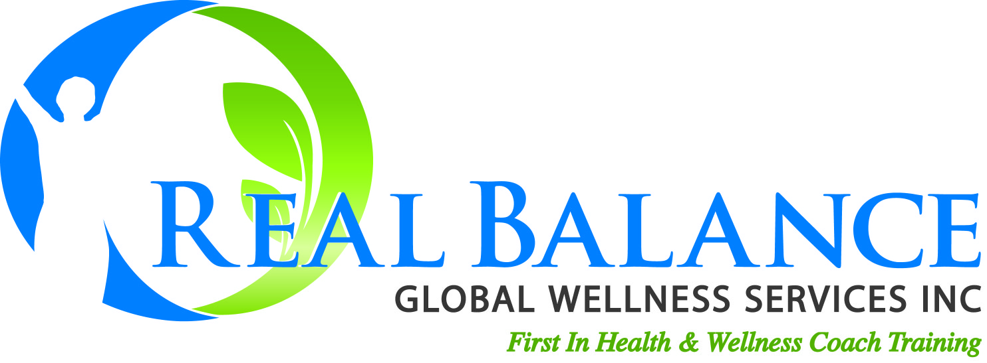

CLIENT RECORDING RELEASE FORM
Purpose: The purpose of this release is to facilitate the professional learning development of - Name of coach: ________
I, (insert name of client) , authorize
(insert name of coach) , to record and release a recorded coaching session to Real Balance Global Wellness Services, Inc. Information to be released: recorded coaching session on (insert date________________):
Permission to release to:
Real Balance Global Wellness Services, Inc., 738 Country Club Rd., Ft. Collins, CO 80524
I understand that my recorded coaching session(s) will be reviewed only by Real Balance Staff and Assessors who will use it for the sole purpose of assessing the quality and methods of my coaching and may be used for the training of Real Balance assessors. I understand that the information will be kept confidential and will not be shared with any other party.
This release form has been read and reviewed by us and we understand its content. Typed-in signatures are not acceptable.

Client’s Signature: ________________________________
Date: ___________
Coach’s Signature ________________________________
Date: ___________
Language used in this coaching session: _________________________

